ELCT 302
Unmanned Autonomous Car
Technical Manual
Group #2
Short Circuits
December 8th, 2023

I hereby certify that I have complied
with the Spirit and the Letter
of the Carolinian Creed
in preparing this report

Jacob Vaught [Steering Team]
Nicholas George [Driving Team]

Mady Hines [Steering Team]

Riley Hudson [Driving Team]

Department of Electrical Engineering
University of South Carolina
Columbia, SC 29208
Table of Contents
1. Safety Precautions 4
2. Operation 5
2.1 Operation Instructions 5
2.2 System State and LED Indicators 6
2.3 System Response Table 6
3. Bill of Materials 7
4. Circuit Diagram 10
4.1 System Overview 10
4.2 Drivetrain System 11
4.3 Tachometer/Frequency to Voltage Converter 12
4.4 State Inputs & Outputs [LEDs & Buttons] 12
4.5 Magnetic Distance Sensors 13
4.6 Full Circuit Diagram 13
5. Troubleshooting 19
5.1 Common Issues and Solutions 19

1. Safety Precautions
- Pre-Power Vehicle Inspection:
  - Conduct a thorough inspection of all accessible circuits before activating the vehicle.
  - Ensure no components are detached, loose, or missing.
  - Resolve any irregularities to prevent damage.
  - Areas to check:
- Battery cable integrity.
- Solder connections.
- Breadboard connection security.
- Placement of integrated circuits (ICs).
- Exposure of wire contacts.
- Signs of wire melting.
- Other visible physical damages.

- Activating the Vehicle:
  - Post-inspection, connect the two subsystems to the battery cable harness using the red polarized connectors.
  - Ensure the power switch is OFF, facing towards the battery solder joint.
  - Connect the battery using its XT-80 (yellow) connector.
  - Check the harness visually for proper functionality before switching ON.

2. Operation

2.1 Operation Instructions
- Preparing for Operation:
  - Before starting, elevate the drive train wheels off the floor using a wooden block placed under the chassis, near the rear axle.
  - This precaution prevents damage during the boot-up sequence.
  - Then, turn the Power Switch to the ON position.

- Modes of Operation:
- SLEEP Mode:
  - Initial standby mode post battery connection.
  - No control LEDs illuminated.

- STOP Mode:
  - Activate before placing on track via pressing the bumper or red button.
  - Red LED indicates STOP state.

- ERROR Mode:
  - Red LED indicates ERROR state.
  - Triggered by off-track detection, obstacle encounters, or low battery.
  - Vehicle halts operation under these conditions.

- WAIT Mode:
  - Advised post-track placement.
  - Activated via the yellow button; Yellow LED illuminates.
  - Affects steering but not drive subsystem.
  - Vehicle switches to ERROR state upon detecting any issues.

- GO Mode:
  - Start operation with black button.
  - Green LED signifies activation.
  - Vehicle begins driving sequence unless an error is detected

- Restarting and Battery Management:
- Restarting Post-Incident:
  - For off-track or obstacle encounters, reset by placing the vehicle back on track and pressing WAIT, then GO.

- Low Battery Management:
  - If low battery is indicated, recharge before resuming.
  - Vehicle prevents subsystem activation under low battery conditions.

2.2 System State and LED Indicators

RED LED | YELLOW LED | GREEN LED | STATE | Issue
X |  |  | STOP or ERROR | ERROR detected or button STOP
 | X |  | WAIT | Waiting Mode. No Issue
 |  | X | GO or NORMAL | Normal Operation in Straight path
X |  | X | GO & TURN | Normal operation on slight turns
X | X | X | GO & HARD TURN | Normal Operation on sharp turns
2.3 System Response Table
STATE | System Response
STOP or ERROR | Drivetrain and Steering Systems shut down
WAIT | Steering Activated, Driving left in previous state.
GO or NORMAL | Steering Functioning as normal. Drivetrain speed increased by 4.6%
GO & TURN | Steering Functioning as normal. Drivetrain speed set to default
GO & HARD TURN | Steering is operating normally. The drivetrain's default speed is adjusted, reducing the turning wheel's speed by 4.6% for improved maneuverability.

2.4 System Input and Output Diagram
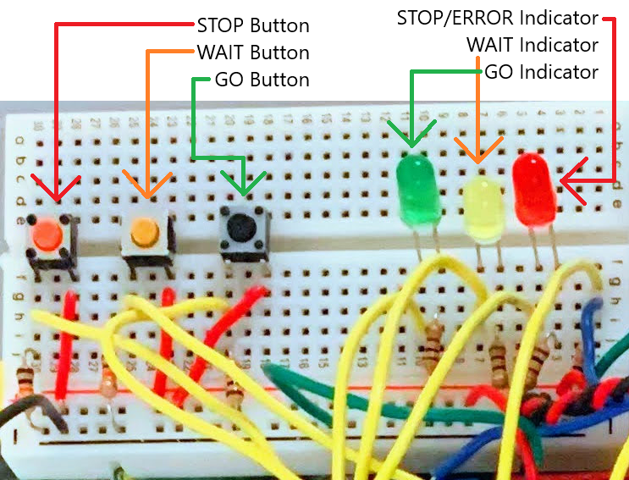

3. Bill of Materials
Part Identification | Description | Quantity
Arduino Uno R3 | ATMEGA328P Microprocessor | 1
Admiral EPR40004X6 | 14.8V LiPo Battery with XT60 Connector | 1
SkyRC SK-100008 | LiPo Battery Charger | 1
Elegoo EL-CP-021 | 32 Pcs PERFboard [Magnetic Sensor] | 1
HiLetGo 3-02-0664-10pcs | 10 Pcs 2 Pole Power Switch [Battery] | 1
readytosky C70 | Set of XT60 and T-plug Connectors | 1
3M 929975-01-06-RK | 12 Position Receptacle Connector 0.100" | 2
3M 929975-01-08-RK | 16 Position Receptacle Connector 0.100" | 4
3M 929975-01-10-RK | 20 Position Receptacle Connector 0.100" | 2
STMicroelectronics L7805CV | Linear Voltage Regulator IC [5V 1.5A Output] | 1
Elegoo ‎US-EL-CP-009 | 600 Pcs Assorted LED set | 1
NTE Electronics 1N4733A | Zener Diode 5.1 V 1 W ±5% Through Hole | 1
Microchip Technology TC4428 | Low-Side Gate Driver IC 8-PDIP | 1
Infineon Technologies IRF540N | Single N-Channel Power MOSFET | 2
Vishay MBR1060 | 60 V 10A Schottky Diode | 2
Texas Instruments LM2907N | 10 kHz Frequency-Voltage Converter [14 pin] | 2
TT Electronics OPB829AZ | Optical Sensor Through-Beam [Tachometer] | 2
Digilent 240-131 | Solderless Full-size Breadboard | 3
API Delevan Inc. 4590R-107K | 100 mH Inductor [Magnetic Sensor] | 2
Texas Instruments LM324N | General Quad-Amplifier Circuit [14 pin] | 1
Vishay 1N914TR | 75V 200mA General purpose Diode | 2
Vishay 1N5226B-TR | 3.3V Zener Diode | 2
STMicroelectronics LD1085V50 | Linear Voltage Regulator IC [5V 3A Output] | 1
Optek OPB740WZ | Optical Reflective Sensor [Landmark Detection] | 2
NXP/Freescale TFC-KIT | Freescale Cup Kit Chassis | 1
Mabuchi Motors RN260-CN-18130 | 7.2V DC Motor [Drivetrain] | 2
Adafruit 155 | 5V Servomotor [Steering] | 1

4. Circuit Diagram

4.1 System Overview
The abstract circuit diagram provided represents the vehicle's power system. It features larger red connections symbolizing 14.8V from the Battery, alongside smaller red connections for 5V low-voltage links. Additionally, blue and purple connections are shown, denoting the control circuitry for sensors and indicators.
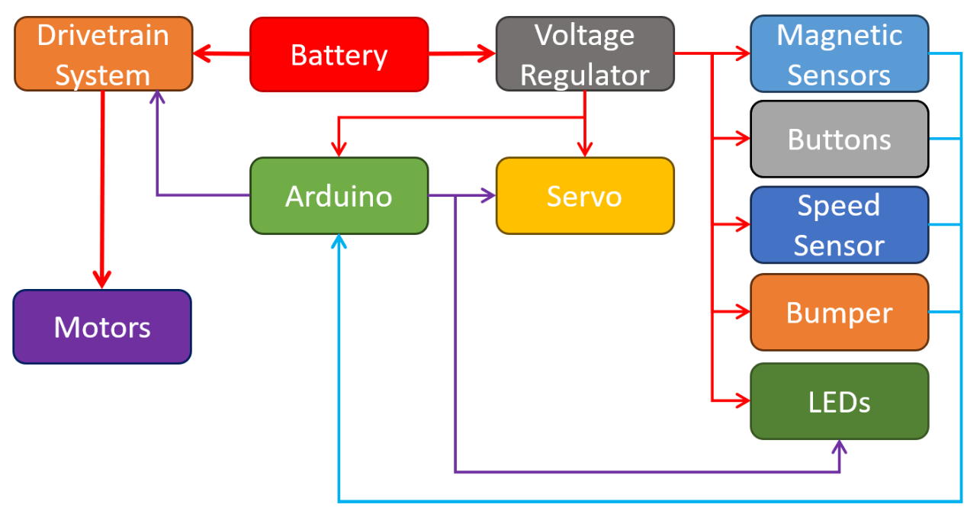
Figure 1: Overall Vehicle Power System

4.2 Drivetrain System
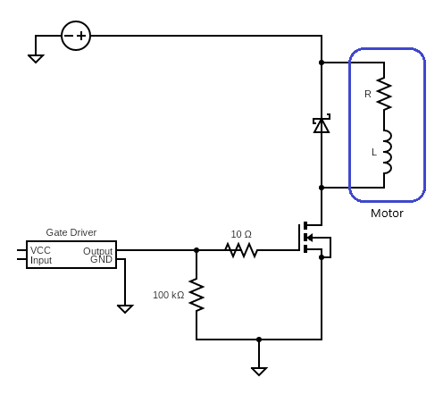
Figure 2: Drivetrain System with Gate Driver to Controller

4.3 Tachometer/Frequency to Voltage Converter
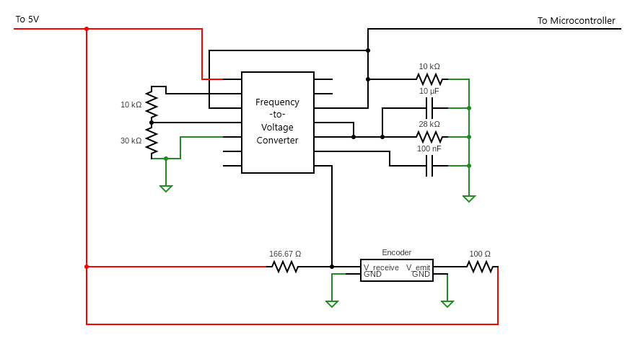
Figure 3: The Frequency to Voltage Converter circuit

4.4 State Inputs & Outputs [LEDs & Buttons]

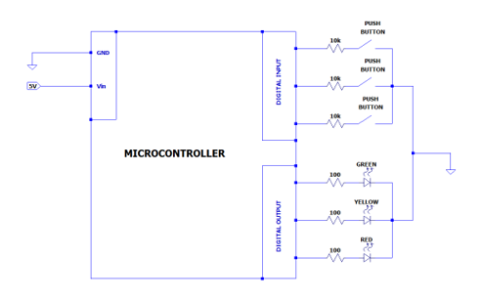
Figure 4: Buttons and LED Circuit

4.5 Magnetic Distance Sensors
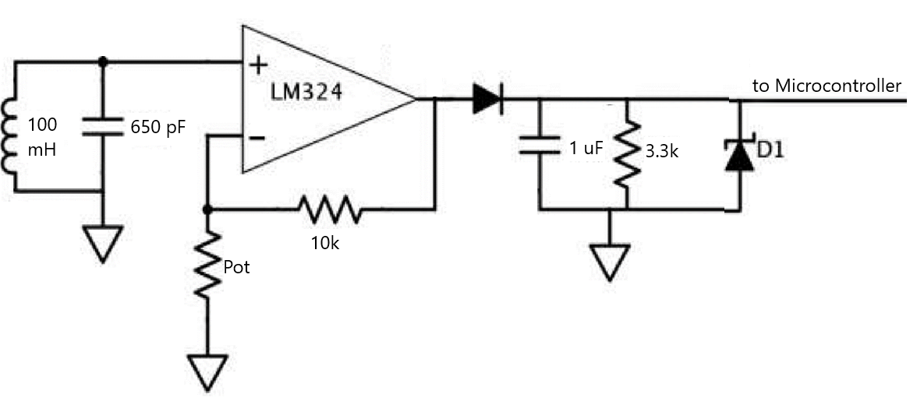
Figure 5: Magnetic Sensor Circuit

4.6 Full Circuit Diagram
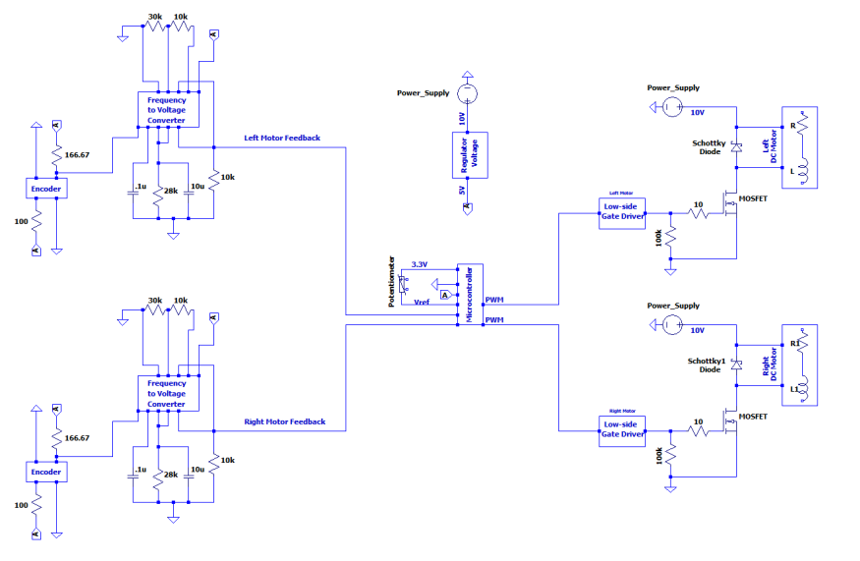
Figure 6: Overall System Circuit

5. Troubleshooting

5.1 Common Issues and Solutions
- Issue: Car doesn't follow track.
  - Solutions:
    - Inspect all wiring to ensure secure connections.
    - Verify that the track is operational.
    - Check if the microcontroller is powered on.
    - Use an oscilloscope to probe the sensor inputs into the microcontroller; replace the sensor or ensure it is powered if no input is detected.
    - Check the battery for any issues.
- Issue: Vehicle not responding to control commands.
  - Solutions:
    - Ensure all buttons are functioning and properly connected to the circuit.
    - Check the LED indicators for corresponding error or state signals.
    - Verify the integrity and connection of the state input and output wiring.
- Issue: Erratic or non-responsive steering.
  - Solutions:
    - Inspect the servomotor connections and functionality.
    - Check the alignment and condition of the steering mechanism.
    - Verify the correct operation of the steering control circuit in the microcontroller code.
- Issue: Drivetrain malfunction or inefficiency.
  - Solutions:
    - Examine the drivetrain system, including motors and their connections.
    - Ensure proper operation of the gate driver to the controller circuit.
    - Check for physical obstructions or damage to the drivetrain components.
- Issue: Inaccurate or non-functioning tachometer/frequency to voltage converter.
  - Solutions:
    - Test the tachometer for accurate readings.
    - Inspect the frequency to voltage converter circuit for any faults.
    - Confirm proper calibration and integration with the vehicle's control system.
- Issue: Magnetic distance sensors not detecting or malfunctioning.
  - Solutions:
    - Test each magnetic sensor for responsiveness.
    - Check the magnetic sensor circuit for proper connections and component functionality.
    - Ensure the sensors are correctly aligned and positioned.
- Issue: Vehicle stops unexpectedly or enters ERROR mode frequently.
  - Solutions:
    - Check for triggers like off-track detection, obstacles, or low battery.
    - Inspect the logic in the microcontroller code that dictates mode changes.
    - Review and test the sensor systems that feed information to the error detection logic.
- Issue: Low battery performance impacting vehicle operation.
  - Solutions:
    - Regularly check and recharge the battery.
    - Inspect the battery connections and the integrity of the cable.
    - Consider battery condition and replace if necessary.

